Differential Amplifiers
Differential amplifier is a basic building block of an op-amp. The function of a differential amplifier is to amplify the difference between two input signals.
How the differential amplifier is developed? Let us consider two emitter-biased circuits as shown in fig. 1.
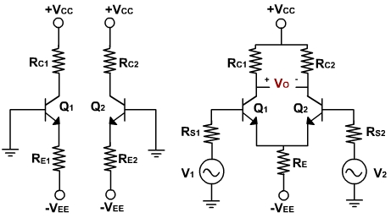
The two transistors Q₁ and Q₂ have identical characteristics. The resistances of the circuits are equal, i.e. R_{E1} = R _{E2}, R_{C1} = R _{C2} and the magnitude of +V_{CC} is equal to the magnitude of –V_{EE}. These voltages are measured with respect to ground.
To make a differential amplifier, the two circuits are connected as shown in fig. 1. The two +V_{CC} and –V_{EE} supply terminals are made common because they are same. The two emitters are also connected and the parallel combination of R_{E1} and R_{E2} is replaced by a resistance R_{E}. The two input signals v₁ & v₂ are applied at the base of Q₁ and at the base of Q₂. The output voltage is taken between two collectors. The collector resistances are equal and therefore denoted by R_{C} = R_{C1} = R_{C2}.
Ideally, the output voltage is zero when the two inputs are equal. When v₁ is greater then v₂ the output voltage with the same polarity as v₁ . When v₁ is less than v₂, the output voltage has the opposite polarity.
The differential amplifiers are of different configurations.
The four differential amplifier configurations are following:
- Dual input, balanced output differential amplifier.
- Dual input, unbalanced output differential amplifier.
- Single input balanced output differential amplifier.
- Single input unbalanced output differential amplifier.
If use two input signals, the configuration is said to be dual input, otherwise it is a single input configuration. On the other hand, if the output voltage is measured between two collectors, it is referred to as a balanced output because both the collectors are at the same dc potential w.r.t. ground. If the output is measured at one of the collectors w.r.t. ground, the configuration is called an unbalanced output.
A multistage amplifier with a desired gain can be obtained using direct connection between successive stages of differential amplifiers. The advantage of direct coupling is that it removes the lower cut off frequency imposed by the coupling capacitors, and they are therefore, capable of amplifying dc as well as ac input signals.

